EXCEL INPUT SPREADSHEET PROCESSING:

1. **Microsoft Excel Input**:

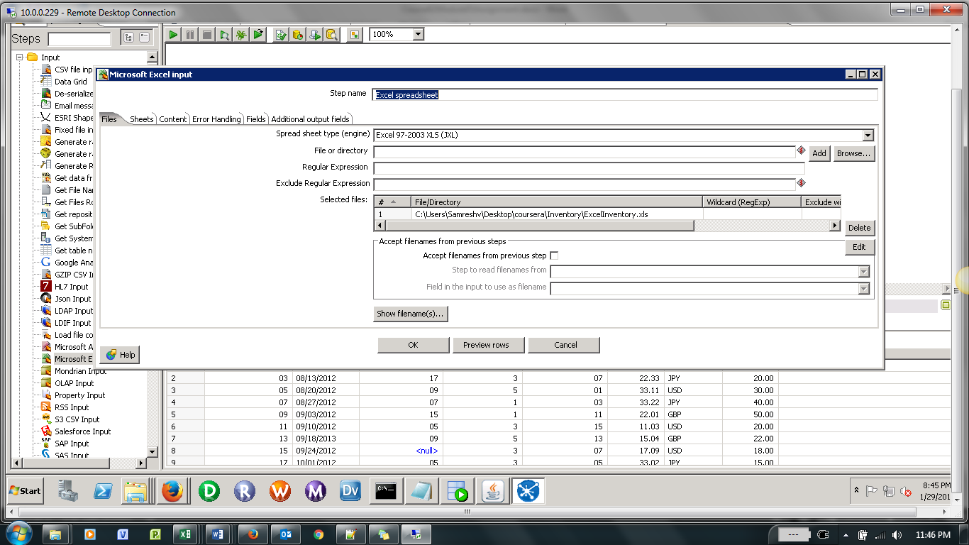

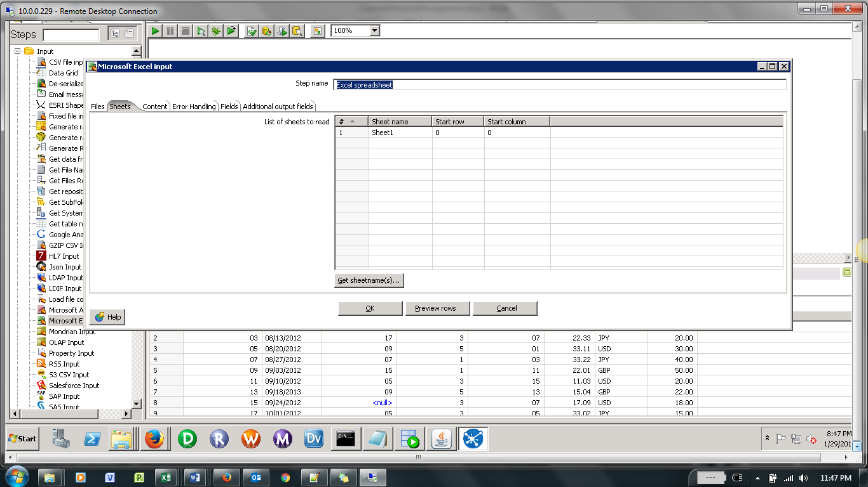

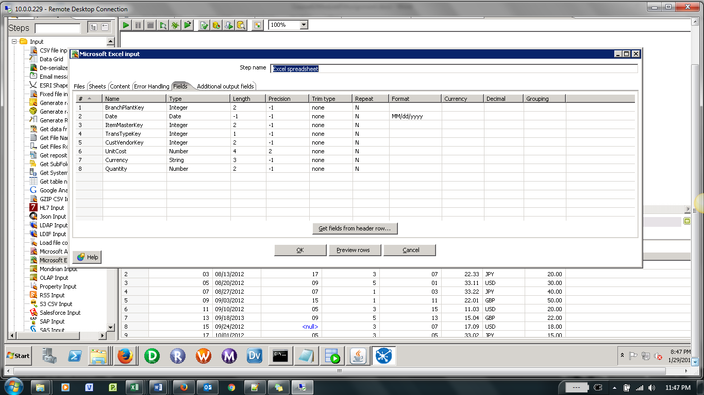

1. **Reject a record if any field is null**

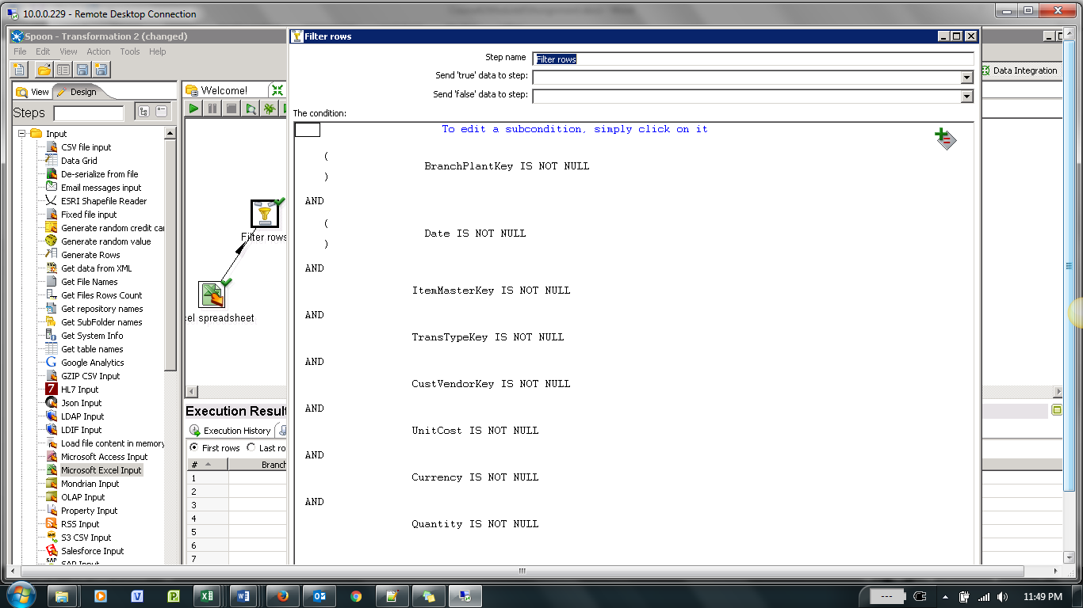

1. **Reject a record if any field value does not match its data type**

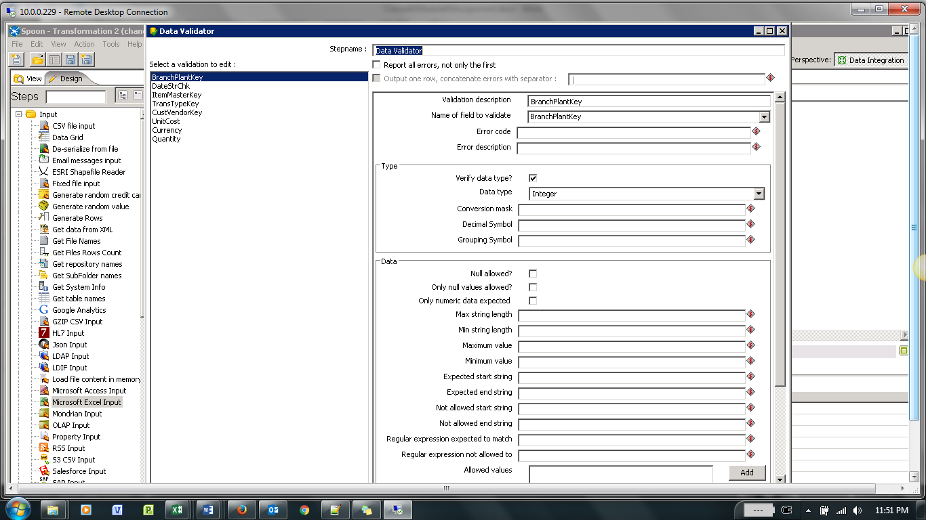

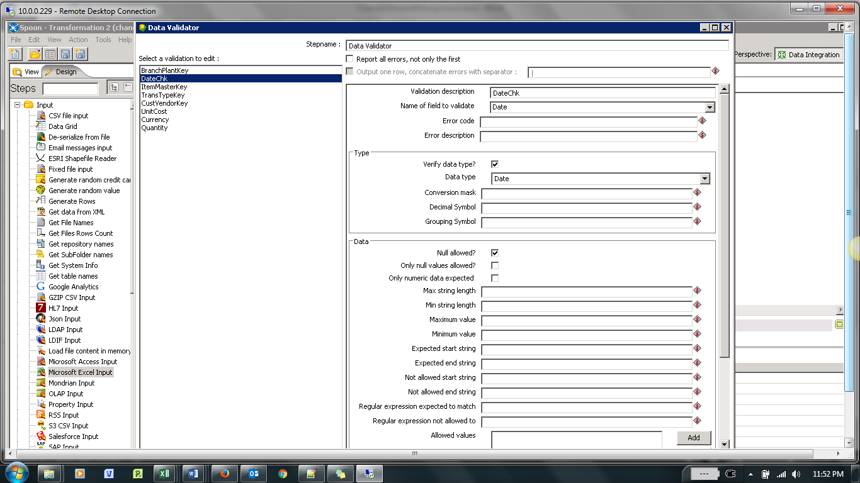

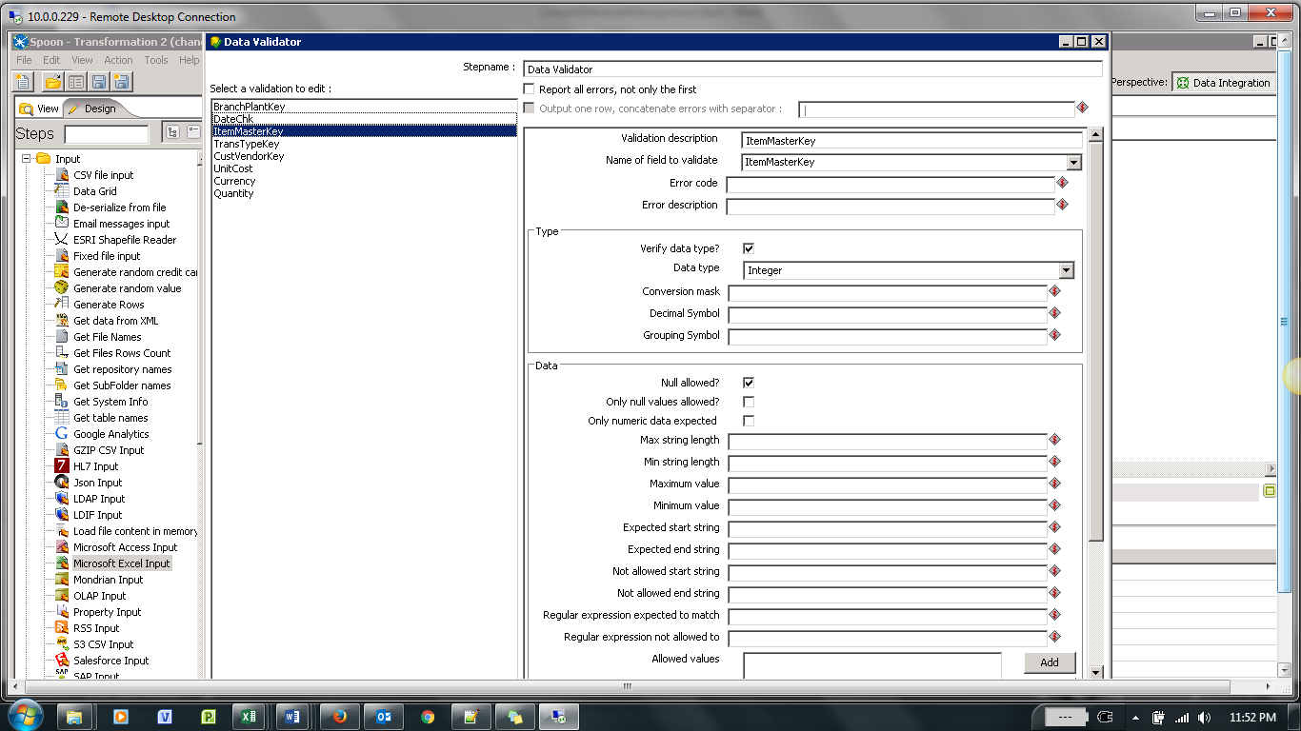

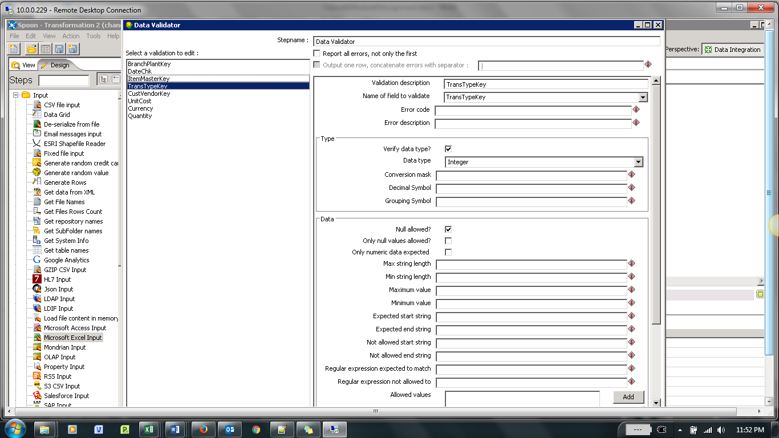

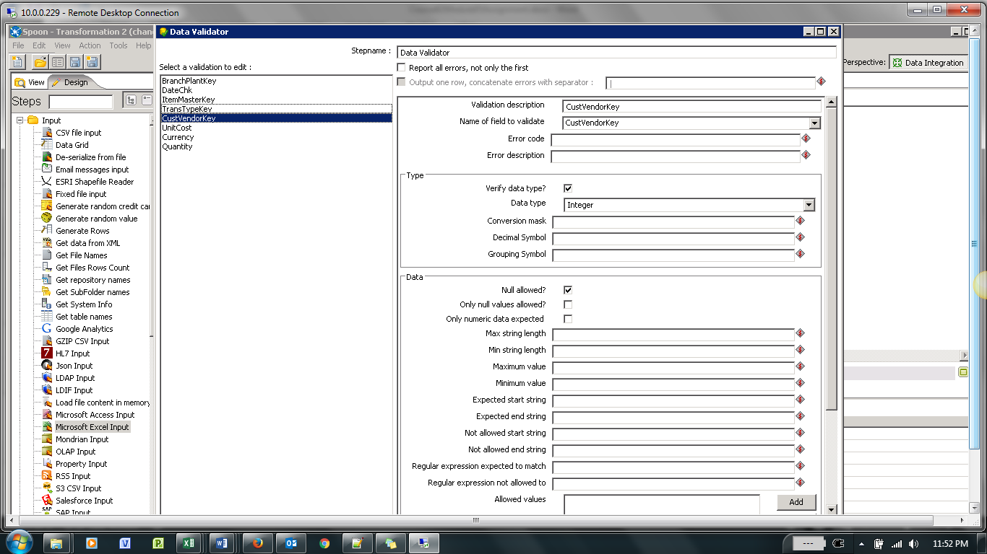

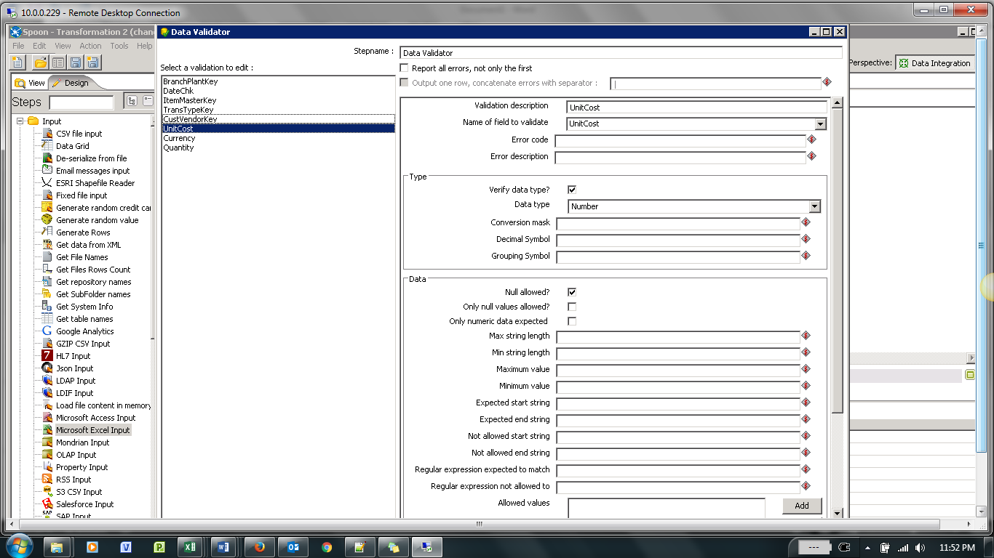

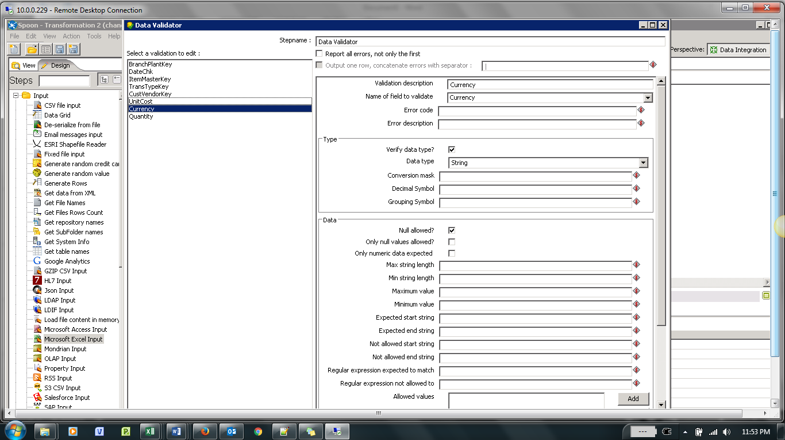

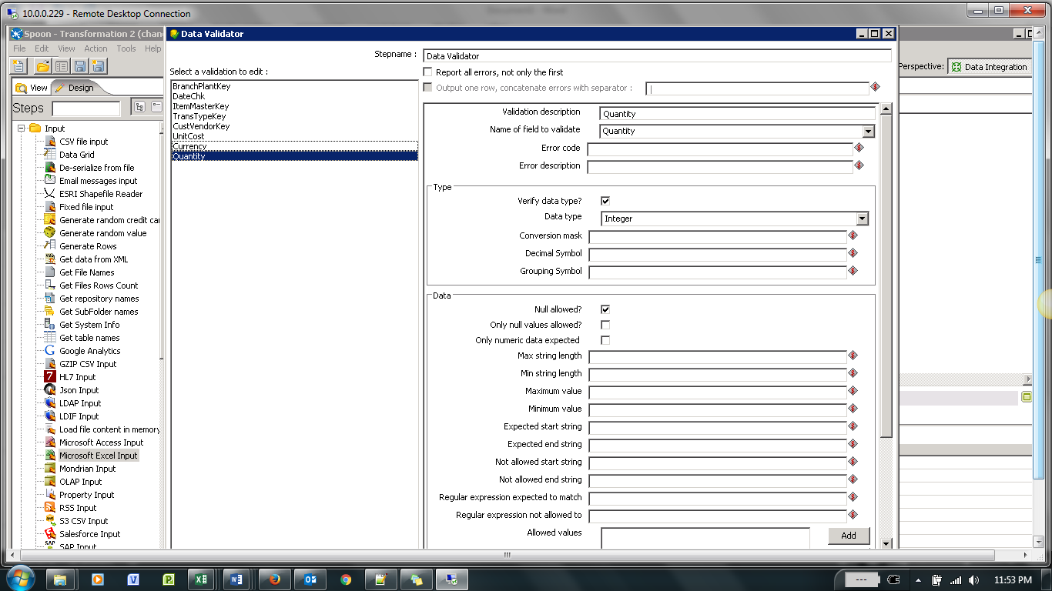

1. **Parse dates in an Excel data source - a Select values step**

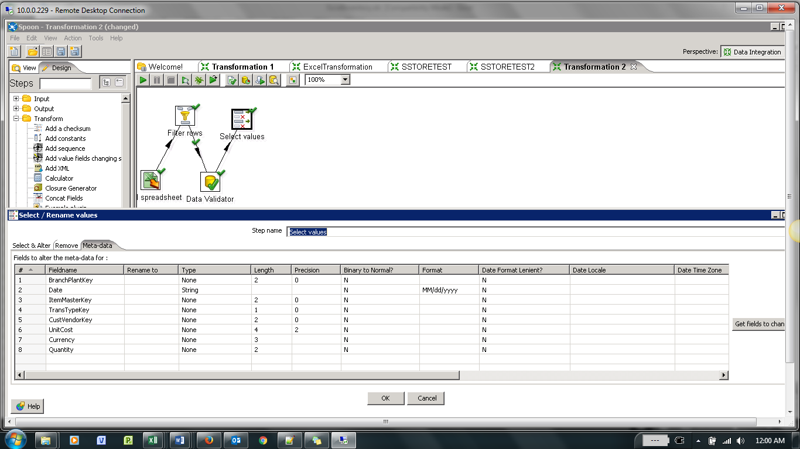

1. **Split Date Field into Date-MM, Date-DD and Date-YYYY**

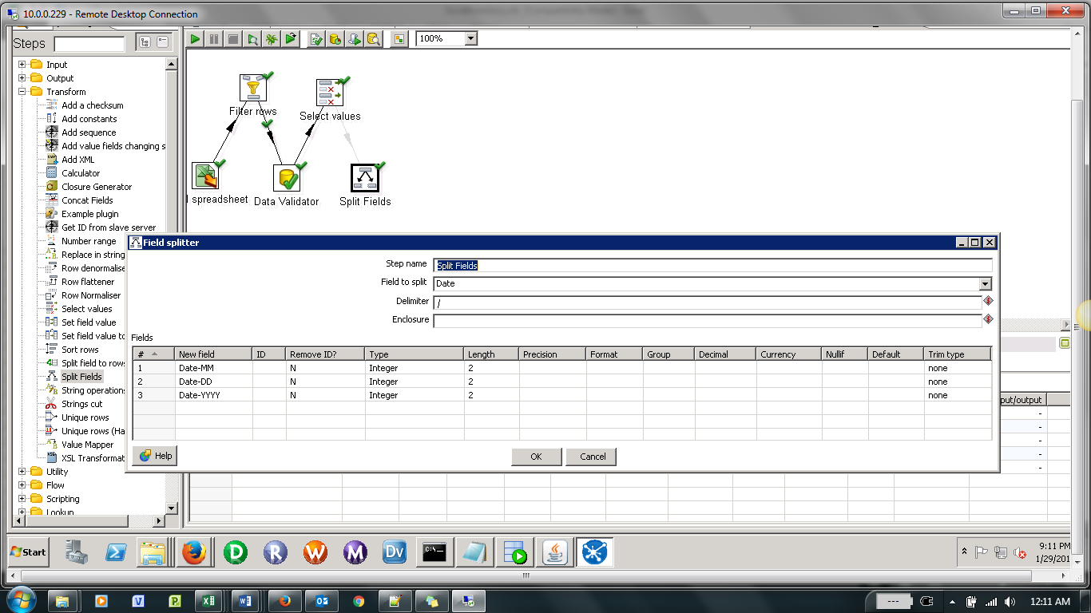

1. Reject invalid foreign key references : Join Date_Dim

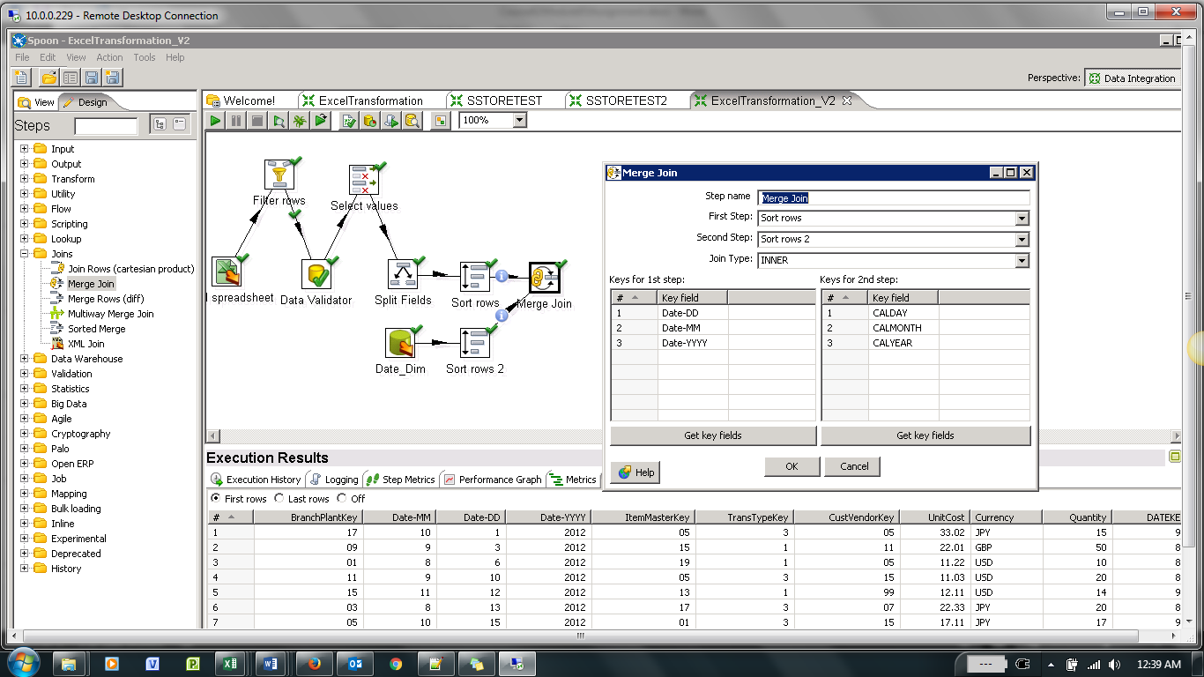

1. Reject invalid foreign key references : Join Trans_Type_Dim

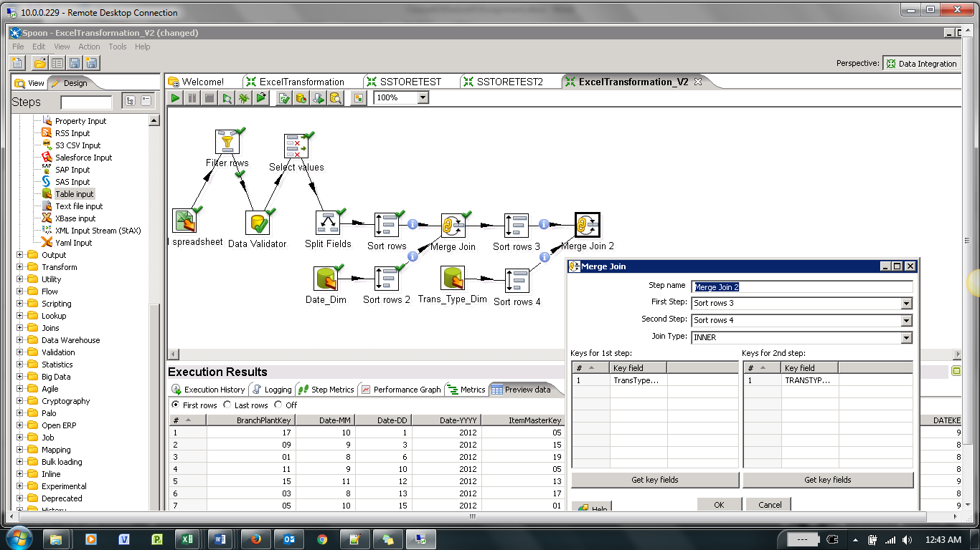

1. Reject invalid foreign key references : Join Cust_Vendor_Dim

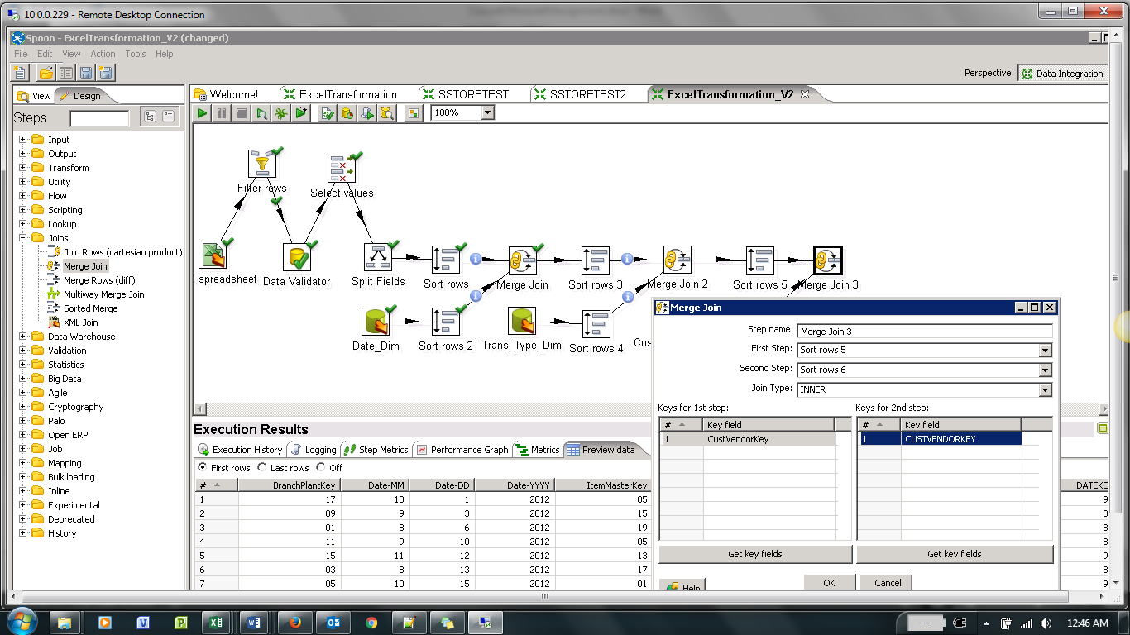

1. Reject invalid foreign key references : Join Item_Master_Dim

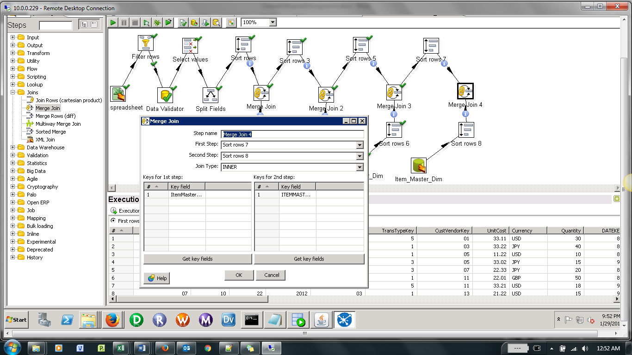

1. Reject invalid foreign key references : Join Branch_Plant_Dim

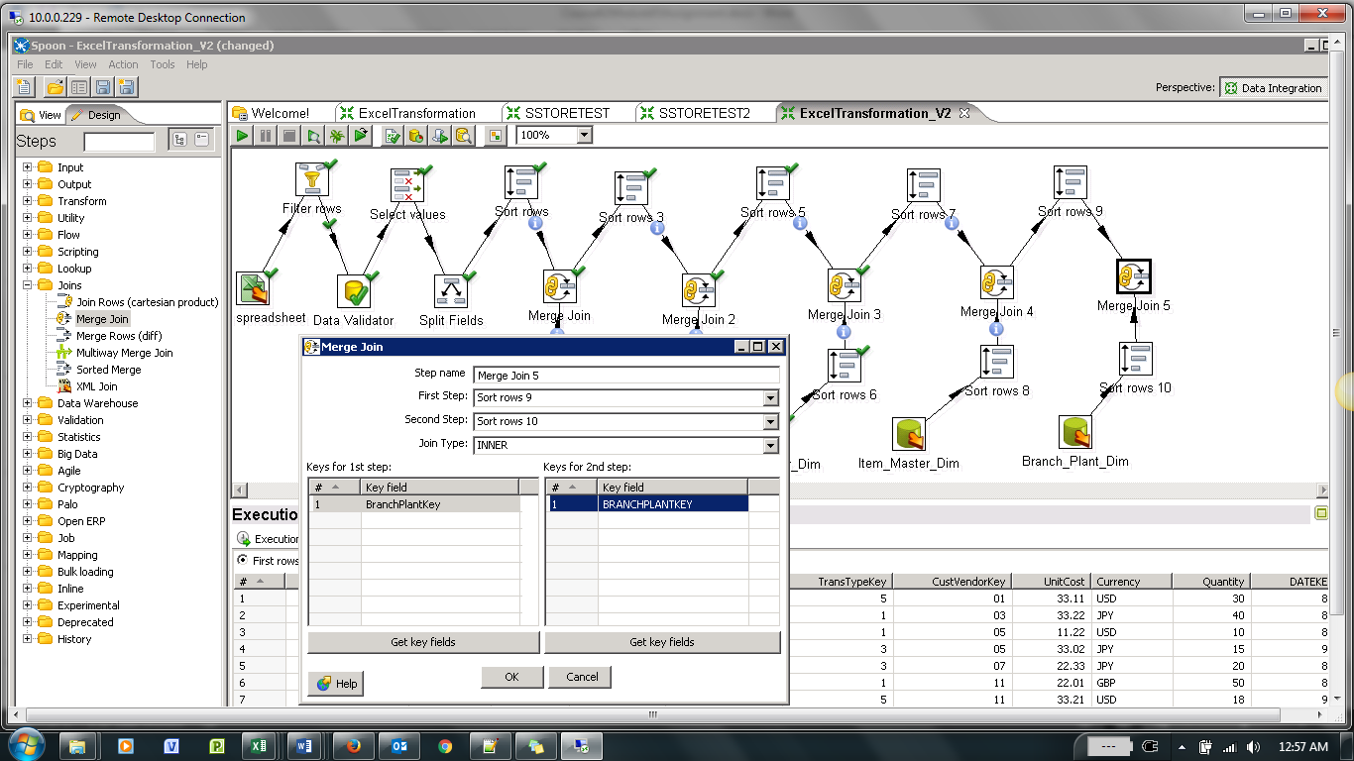

1. Reject invalid foreign key references : Join Currency_Dim

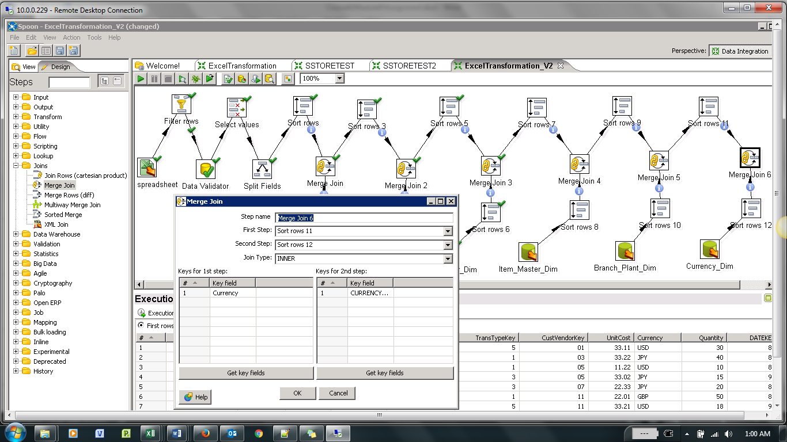

1. **Calculator Transformation for Unit Cost and ExtCost:**

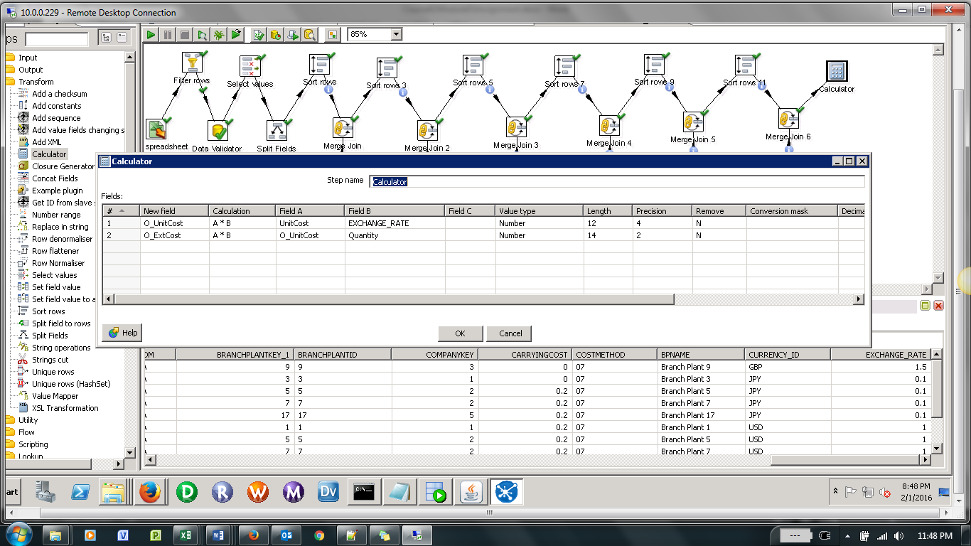

1. **Add Sequence**

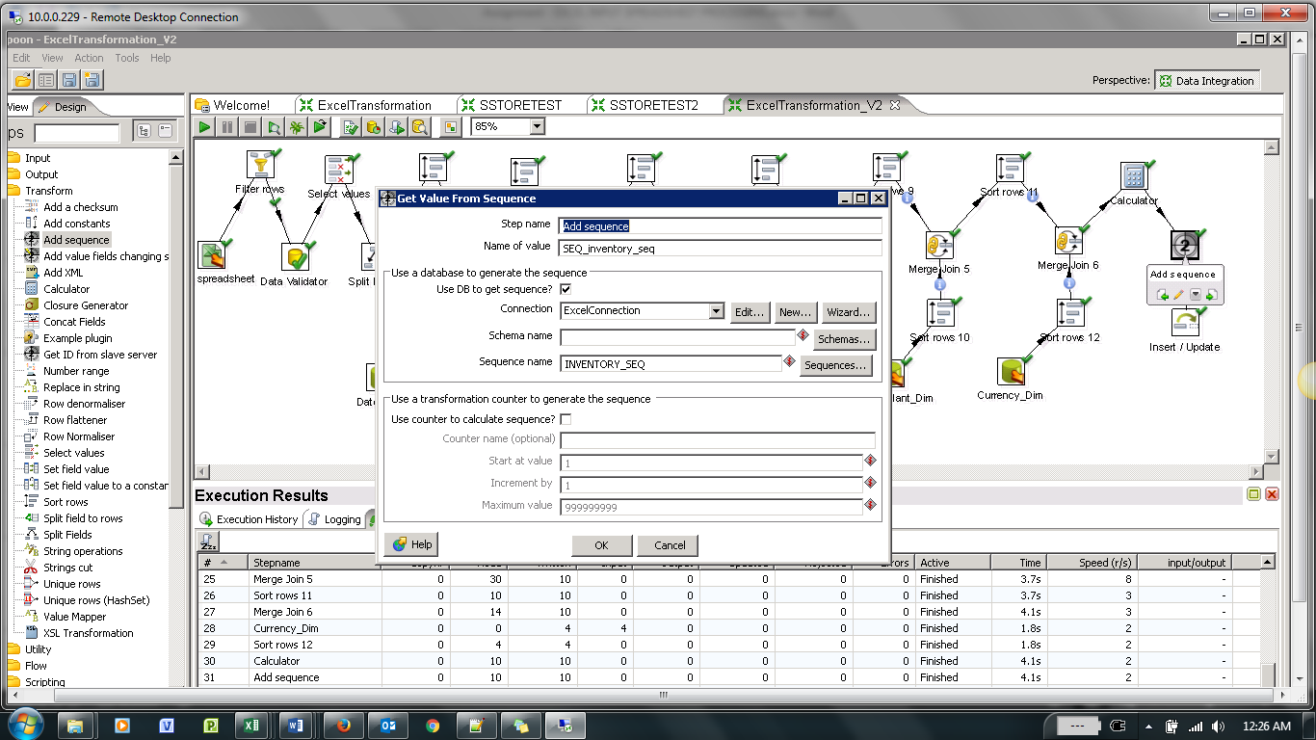

1. **Insert/Update INVENTORY_FACT table:**

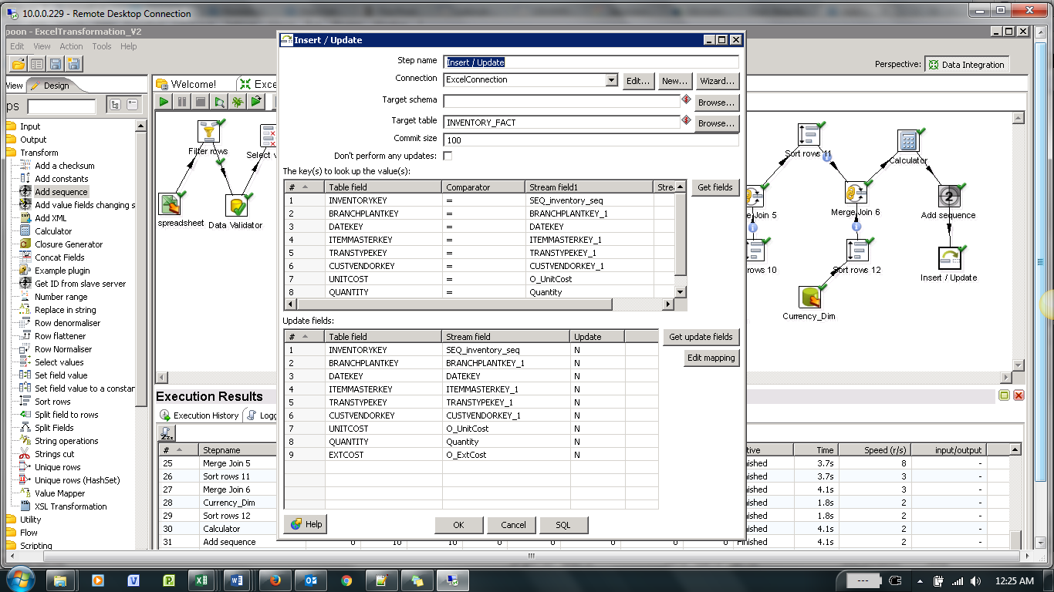

**Complete Transformation:**

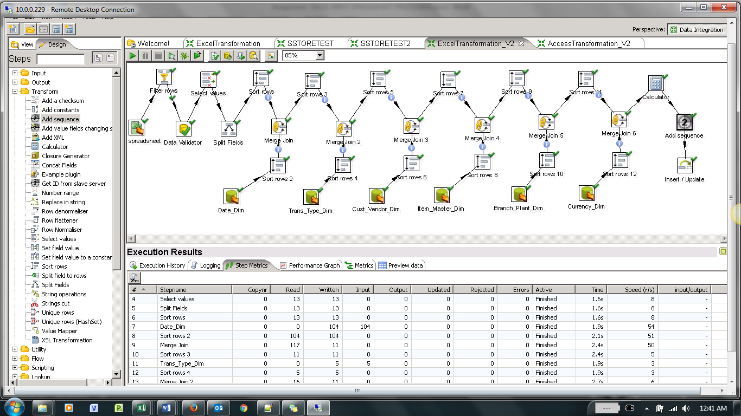

**Execution: Step Output Stats:**

